*Blackjack game*

**1: How to download and install the game.**

All you need to do is download all the files from the repository and compile and run the program.

-You can clone the repository directly to vscode or your choice of text editor through Github.

-You can just copy the whole main file and download the graphics file and font file and put it into the text editor of your choice.

To compile you must use: **g++ -std=c++11 main.cpp -o sfml-app -lsfml-graphics -lsfml-window -lsfml-system**

to run the program you must use **./sfml-app**

If everything is done correctly once you run the game you will get this screen.

**2. Playing the game**

When on the starting screen it will tell you to hit enter to start. The next screen you will see one of the opponent’s cards and 2 cards of your own. The opponents Second card will show the back of the card and the other cards from the starting screen will all disappear.

**Important Note: If you hit enter at any time after the start screen the game will crash.**

The screen above will give you the option to hit which means to ask the dealer for another card. If You go over 21 you will lose.

If you hit S to stand this means you are happy with your hand and are done asking for new cards now the opponent will attempt to get as close to 21 as possible.

Hand Values:

A = 1

Cards 2 – 10 values are equal to the number displayed on the card

Jack, Queen, King all equal 10

**Important Note: A is supposed to be worth 1 or 11 but I ran out of time programming this so A cards are only worth 1.**

**Important Note You must hit H once for a card every time. For S you must continue to hit S for the opponent to get more cards. The opponent will stop automatically if they have a hand value of 17-21 and will lose if they go over 21.**

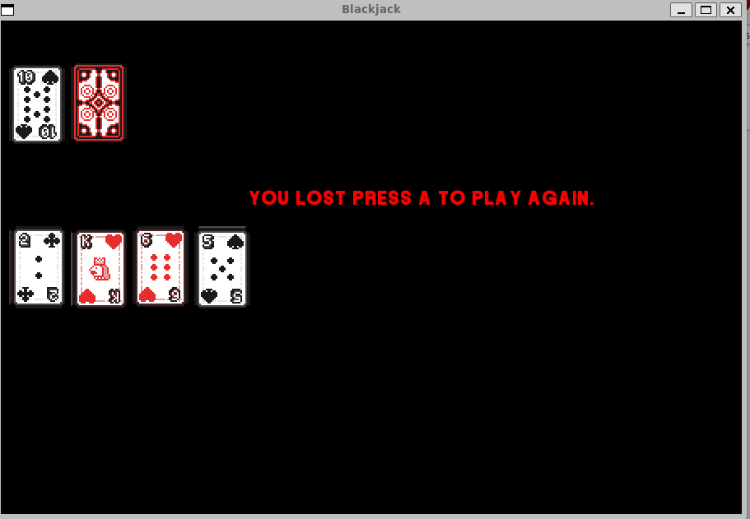

Game over screen

When you hit A the hand will restart you will have 2 cards and will see only 1 card of the opponent.

Win Screen

**3.Things I will Improve over the summer**

* Use buttons instead of keyboard commands
* Program the A card to have the value of 1 or 11
* Have the computer loop without player input
* Have a tie screen

In closing I had a lot of fun making the game using graphics and learned a lot. There was a lot of times I wanted to give up and glad I got as far as I did. I want to be a game designer after I am done with school and this project gave me a lot of ideas for the summer to make new games and play around.